УДК 81`33

**THE CHAT-AND-LEARN MOBILE APPLICATION TO HELP STUDENTS WHO STUDY RUSSIAN LANGUAGE**

**G. E. Proskurin**, **M. A. Perevoznikov[1]**

Student, Siberian Federal University, Russia, Krasnoyarsk   
Scientific supervisor – senior teacher N.N. Slepchenko

*Siberian Federal University, Russia, Krasnoyarsk*

Exchange programs and studying abroad is a common practice used by Universities in modern times. The popularity of such practice comes from a variety of reasons: students have interests in courses or disciplines in some particular field that could only be available in foreign Universities, the interest in international partnership programs between countries, and students’ personal preferences. The process of moving to another country and getting acquainted with a new culture might be quite challenging itself. The lack of the necessary language aptitude level, not close enough to native speakers’ ones, has a negative impact on the process of learning and adaptation in another country. Such problems could cause serious misunderstanding while working in a group project or some difficulties when learning new materials.

At the preliminary stage of our research we have been trying to find a demanded but not overused area to cover so far. After interviewing two exchange students from China, who study at Moscow Pedagogical State University (MPGU); we have concluded that one of the commonest problems for such students is the flexibility of the language use. People who study the Russian language often come across certain expressions (i.e. collocations, idioms, etc.) or some examples of pun (*pun* – the clever or humorous use of a word that has more than one meaning *(Oxford Dictionary)*), so they have practical difficulties in understanding their meanings and in using them appropriately. Russian language is rich in such expressions, because of its vast cultural heritage and folklore, and so they are used quite often in daily conversations. Without given context or required language knowledge, these expressions might sound confusing and misleading. To avoid such misunderstandings, non-Russian speakers should learn and add them in their active vocabulary.

However, learning such expressions is quite a difficult task. It is not enough just to learn the definition from dictionary as it can be unclear or even vague and, without vivid examples, it is hard for the students to find the correct application in conversations. In order to make the process of learning such expressions more accessible and less troublesome we decided to supply the materials witha cultural remark, origin or background of the phrase alongside the detailed definition and usage example in casual speech, providing it in form of a correct application showcase from popular media.

Despite the significance of this problem, at the beginning of our application development there were no counterparts found in Google Play or AppStore, meaning novelty of our research.

The main purpose of our application is to aid foreign students in learning the Russian language in obtaining professional education, to help understand the expressions and learn to adequately apply them.

The reason behind mobile application format was the fact that people prefer convenience and accessibility. Such format provides following advantages:

* Simple usage of the application;
* Possibility to easily change and adjust the material provided in application;
* Accessibility and user-friendliness of interface.

The Chat and Learn Application is developed on Android platform and, in case of positive feedback, in future it might be developed for IOS platform as well.

The application consists of following parts:

* **The textbook.** It is the main function of the application, which consists of studying materials and usage examples (such as movie fragments, books, etc.) in a form of short lessons which help students understand how to correctly apply the expressions. Materials are used in a way that includes some cultural aspects alongside. In order to maintain the relevancy, we used the following dictionaries: Oxford English Dictionary [1] and MAC dictionary [2]. Currently only one course of studying materials was accumulated with the help of Philological Faculty students of Moscow Pedagogical State University.
* **The test.** There is a short test at the end of each lesson. There a student should choose the correct option from one of the presented answers to test the knowledge of currently studied material. The application does not have any ‘strict’ progress control. Students rate their progress themselves and are allowed to revisit all the materials.
* **The chat.** An important part of the application is the chat feature, which joins two users in conversation. The purpose of this feature is to help practice the acquired knowledge. The expressions in messages are highlighted and explanation commentary can be accessed for each expression. We believe this to be an important feature, because students might have trouble spotting different expressions.

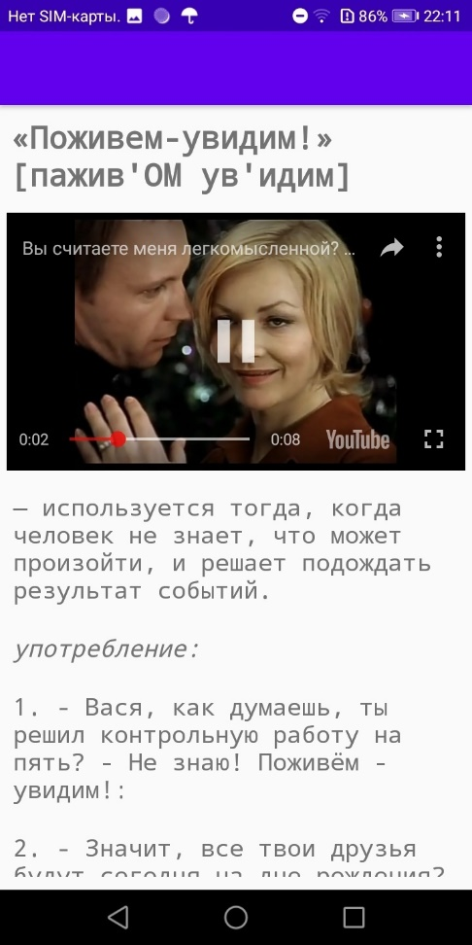 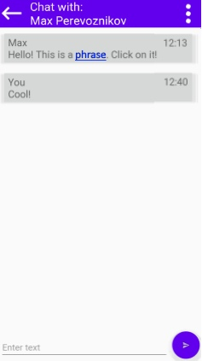

Fig. The application interfaces a) textbook b) chat.

In conclusion we believe that finding a solution for this problem is an important task, because the Russian language is becoming a popular trend, which is associated with its active development in international cooperation between universities. Our Application is aimed to help students adapt to Russian manner of speech in order to improve their studying progress and life skills in general. The Application launch is planned in near future, and it is targeted to be used by exchange students studying at Universities of Russia.

**References**

1. Oxford English Dictionary [Electronic resource]. URL: https://www.oed.com/ (Date of access: 05.04.2020).
2. MAC dictionary [Electronic resource]. URL: https://gufo.me/dict/mas (Date of access: 05.04.2020).
3. О молодежном сленге, юмористическом тексте и психолингвистике на Университетской субботе. Государственный университет русского языка им. А.С. Пушкина. [Electronic resource]. URL: https://www.pushkin.institute/news/detail.php?ID=15666 (Date of access: 05.04.2020).
4. GitLab project Russian learning [Electronic resource]. URL: https://gitlab.com/Niruksorp/learning-russian (Date of access: 05.04.2020).

1. © Proskurin G.E., Perevoznikov M.A., Slepchenko N.N., 2020